Date | 10 July 2026
Team ID
Project Name | Comprehensive Analysis and Dietary Strategies with Tableau: A College Food Choices Case Study
Maximum Marks

Data Preprocessing
- Connected the food_coded.csv dataset to Tableau for data analysis and visualization.
- Verified the data schema and ensured that all fields were assigned the correct data types (String, Number, and Categorical).
- Checked the dataset for missing, null, and inconsistent values. The source dataset was already cleaned, so no major data cleaning was required.
- Renamed and standardized field names where necessary to improve readability and consistency during analysis.
- Created aliases for coded categorical values such as Gender, Breakfast, and Comfort Food Reasons to make the visualizations easier to understand.
- Created calculated fields to classify students into Healthy and Unhealthy categories based on their healthy feeling scores.
- Created parameters to dynamically analyze different food categories (Greek Food, Indian Food, Italian Food, and Persian Food) and vitamin consumption.
- Validated all fields, calculated fields, and parameters before creating visualizations and dashboards to ensure accurate analysis

Calculated Fields Used
- Health Category – Classifies students into Healthy and Unhealthy based on their Healthy Feeling score.
- Calculation1 – Used for dynamic analysis of Vitamins Consumption.
- Calculation2 – Used for dynamic selection and analysis of different cuisine preferences through parameters.

Parameters Used
- Parameter 2 – Used to dynamically select and analyze Vitamins Consumption.
- Parameter 3 – Used to switch between different cuisine types (Greek Food, Indian Food, Italian Food, and Persian Food) for comparative analysis.

Business Questions with Visualizations
1. What are the key health and academic indicators of college students?
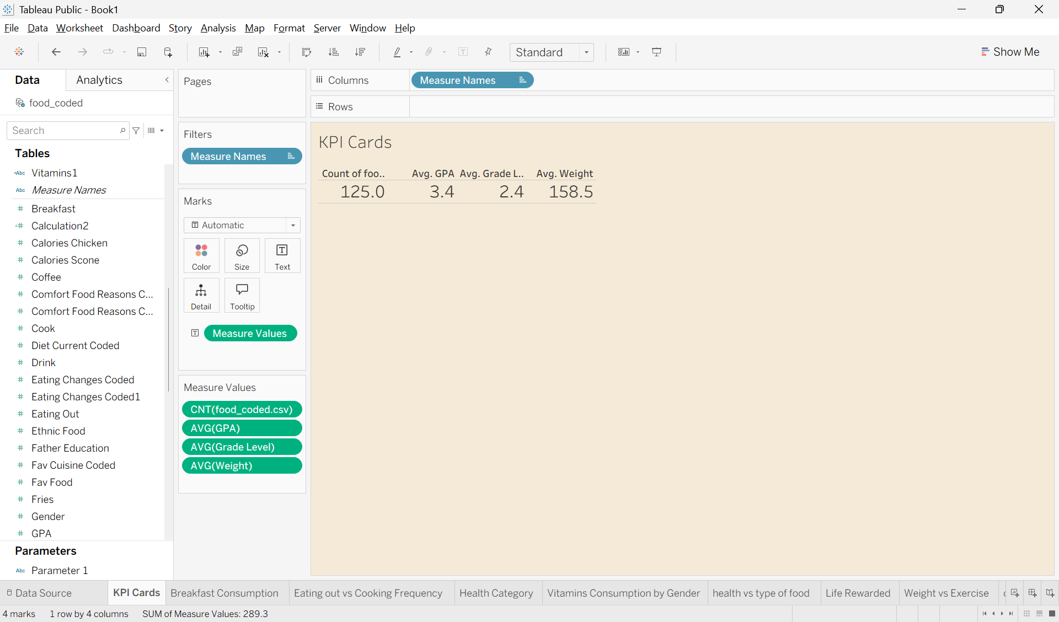

2. What are the most preferred breakfast choices among college students?

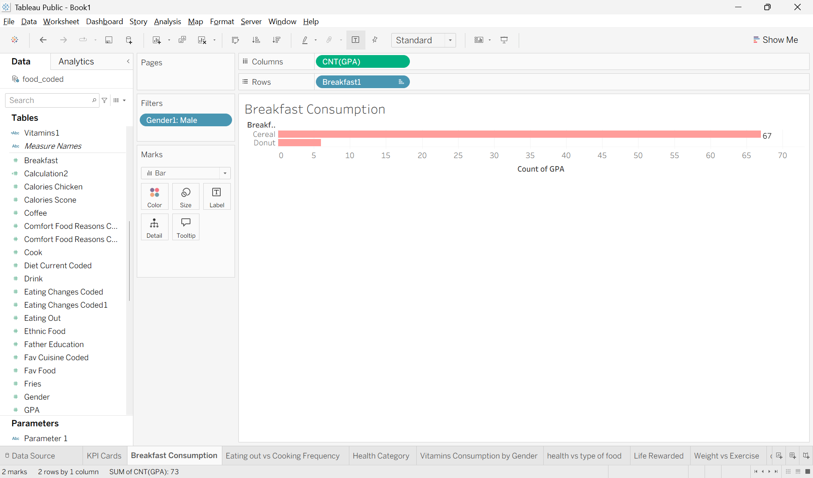

3. How frequently do students eat outside compared to cooking at home?
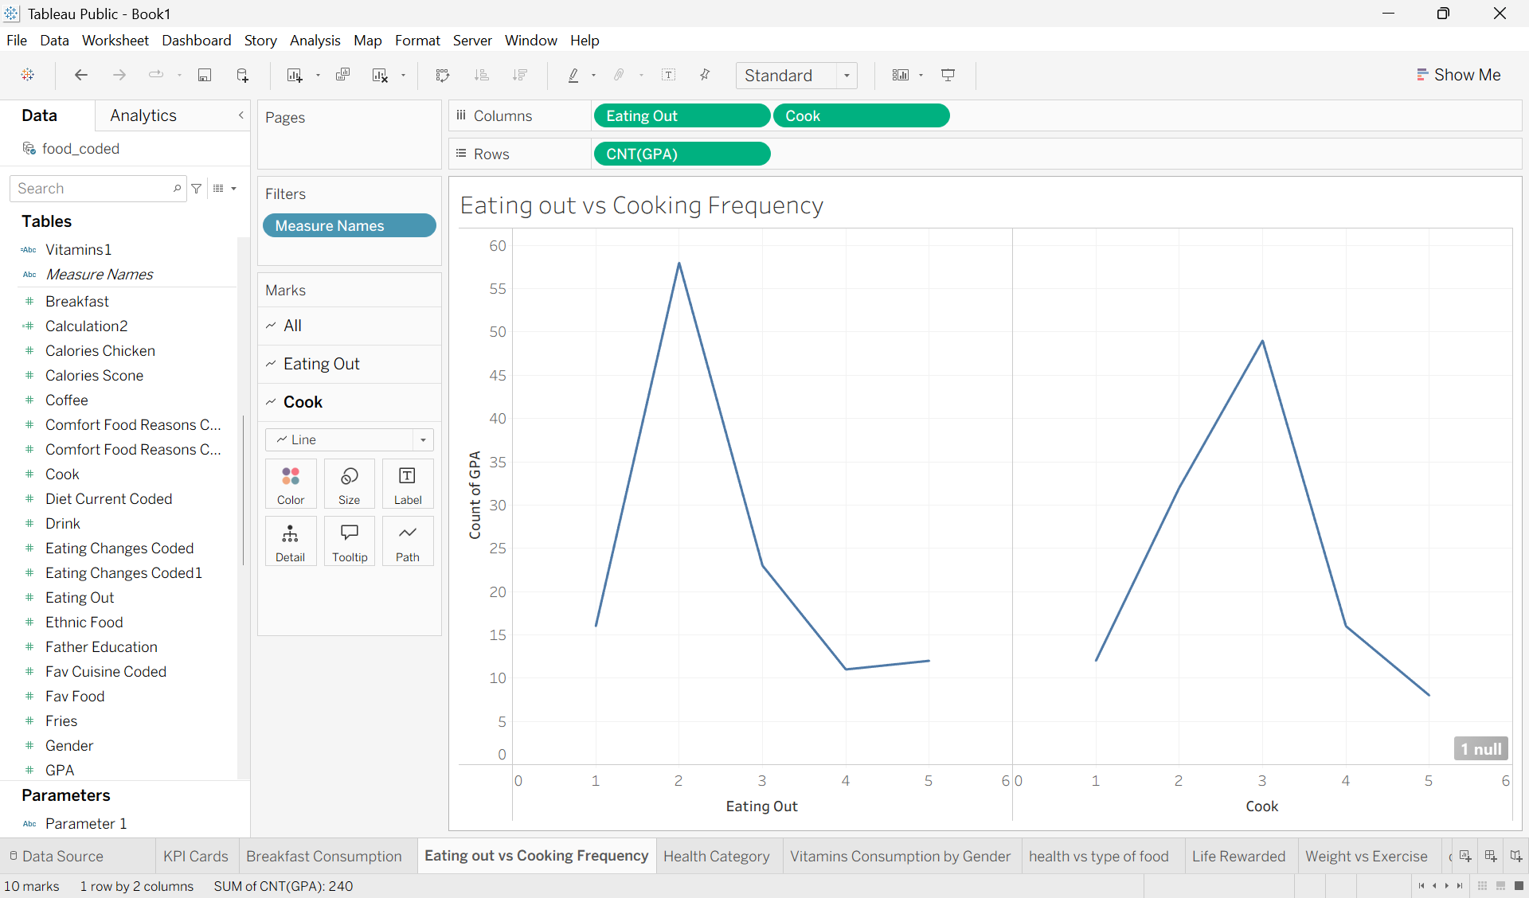

4. How does health status vary across different genders?

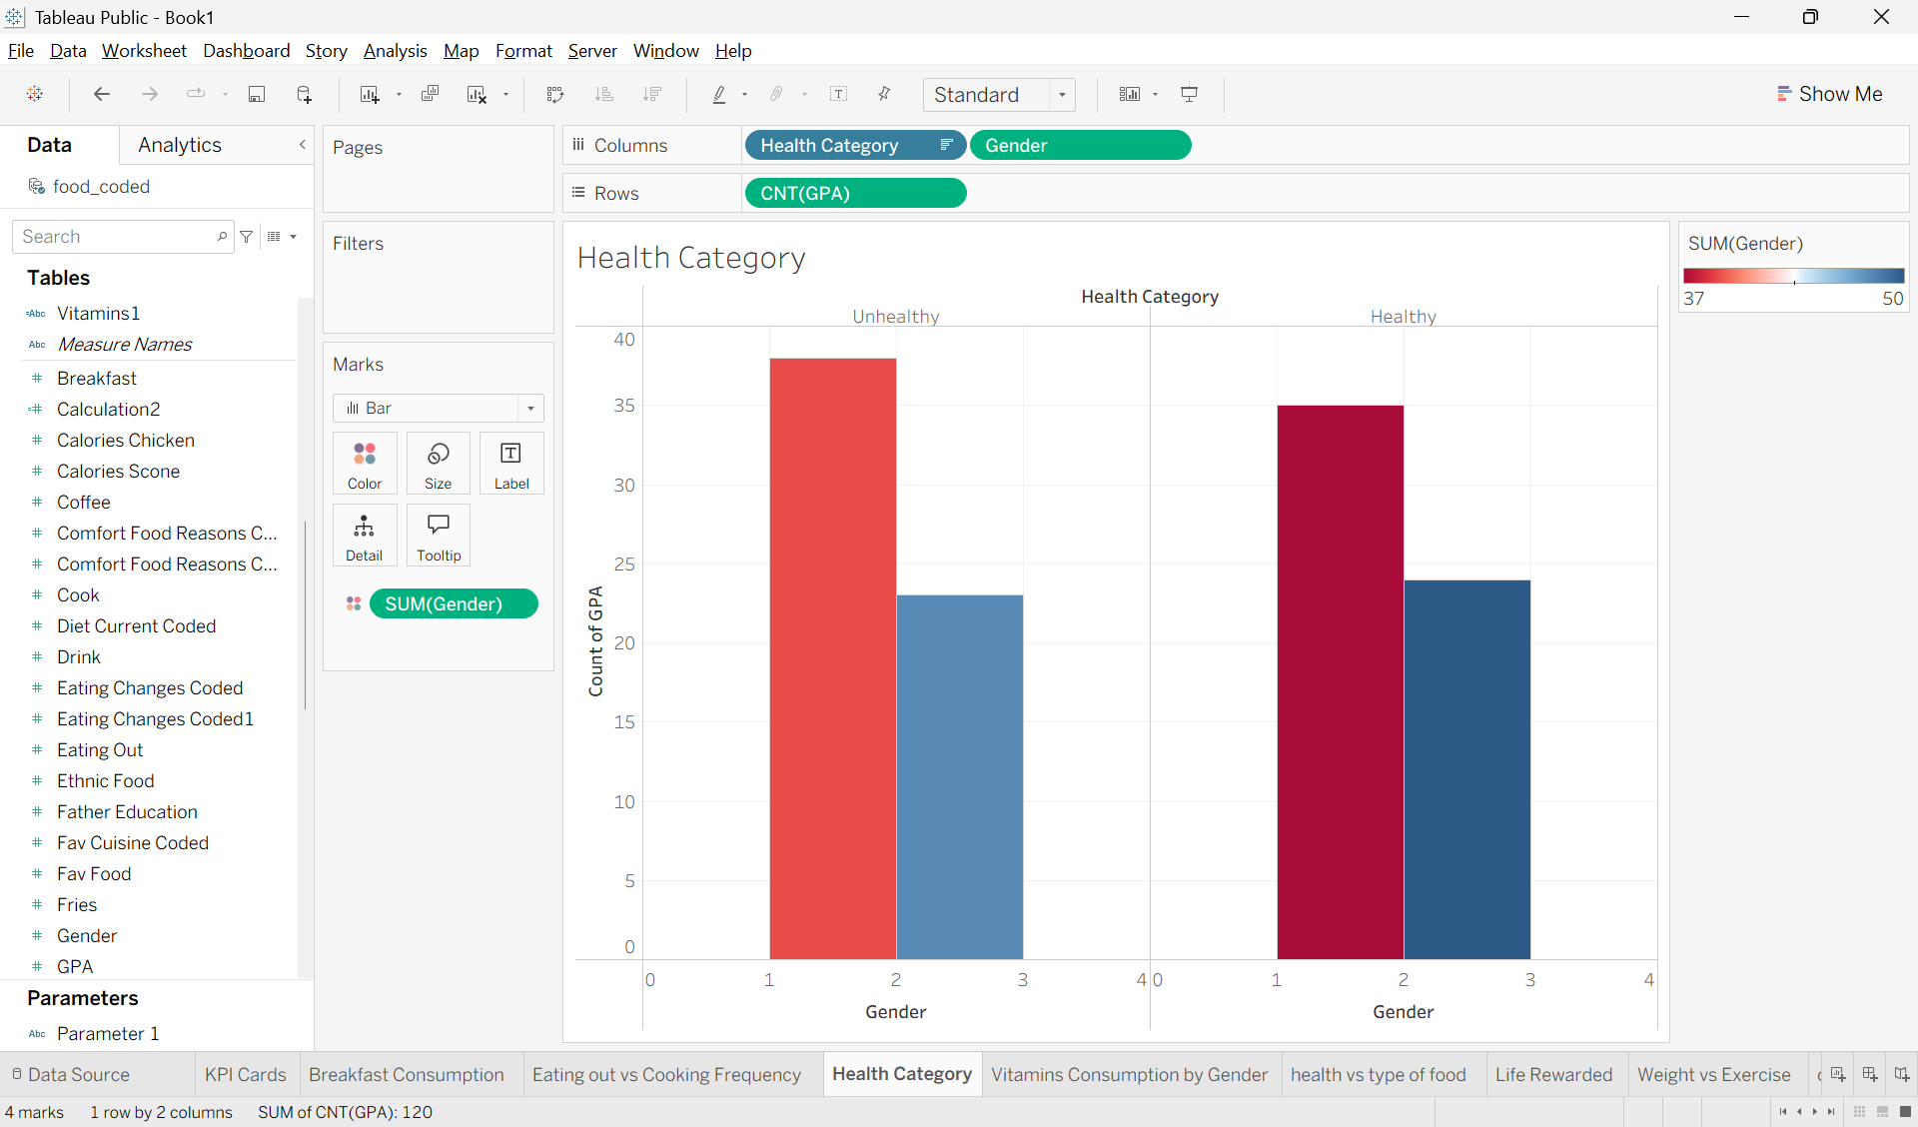

5. How does vitamin consumption differ between male and female students?

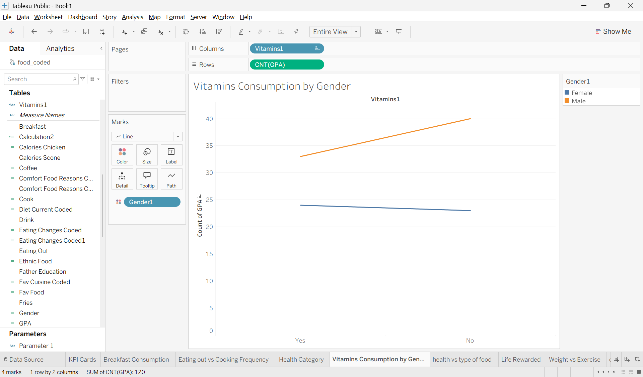

6. How does health status relate to Greek food consumption?

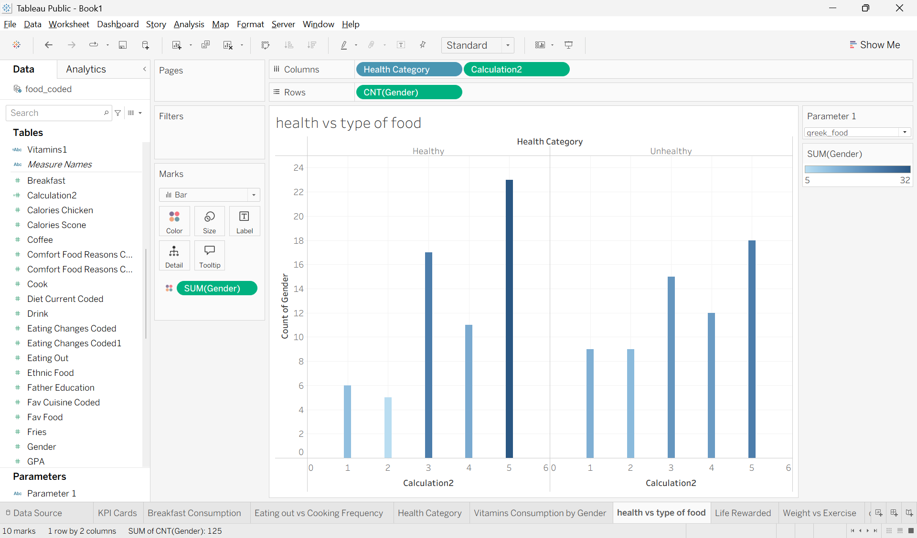

7. How are healthy feelings related to students' life satisfaction?

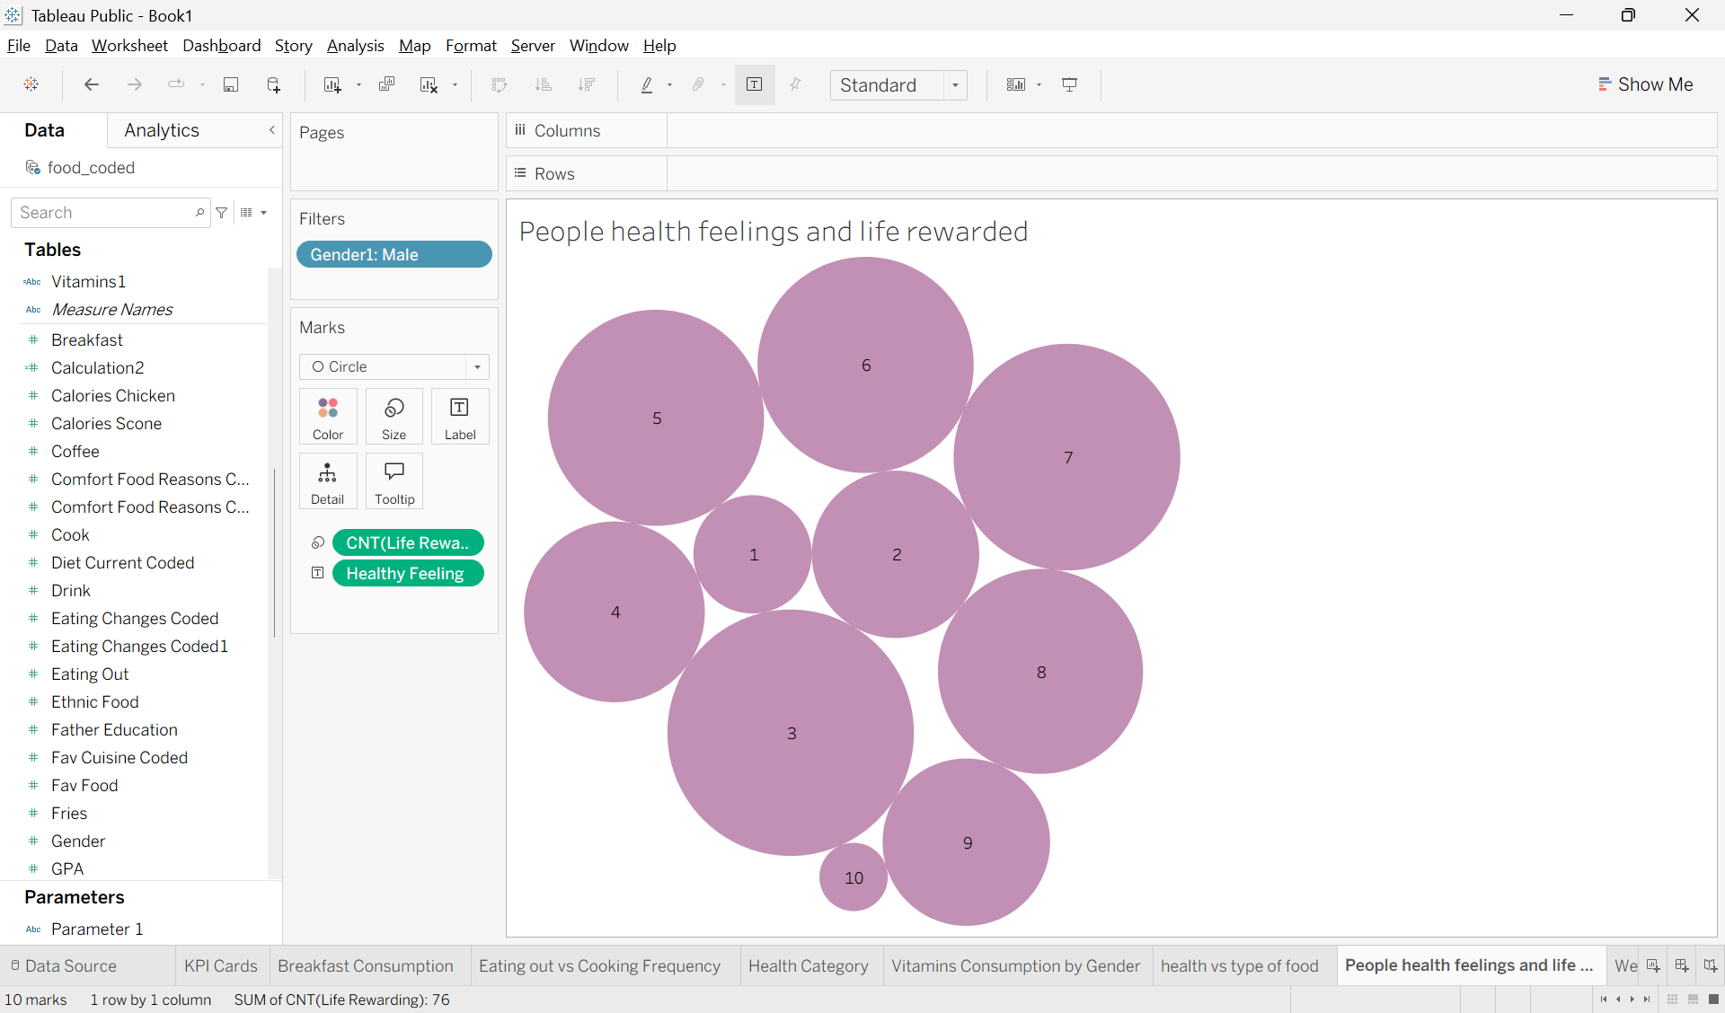

8. What is the relationship between students' weight and exercise frequency?

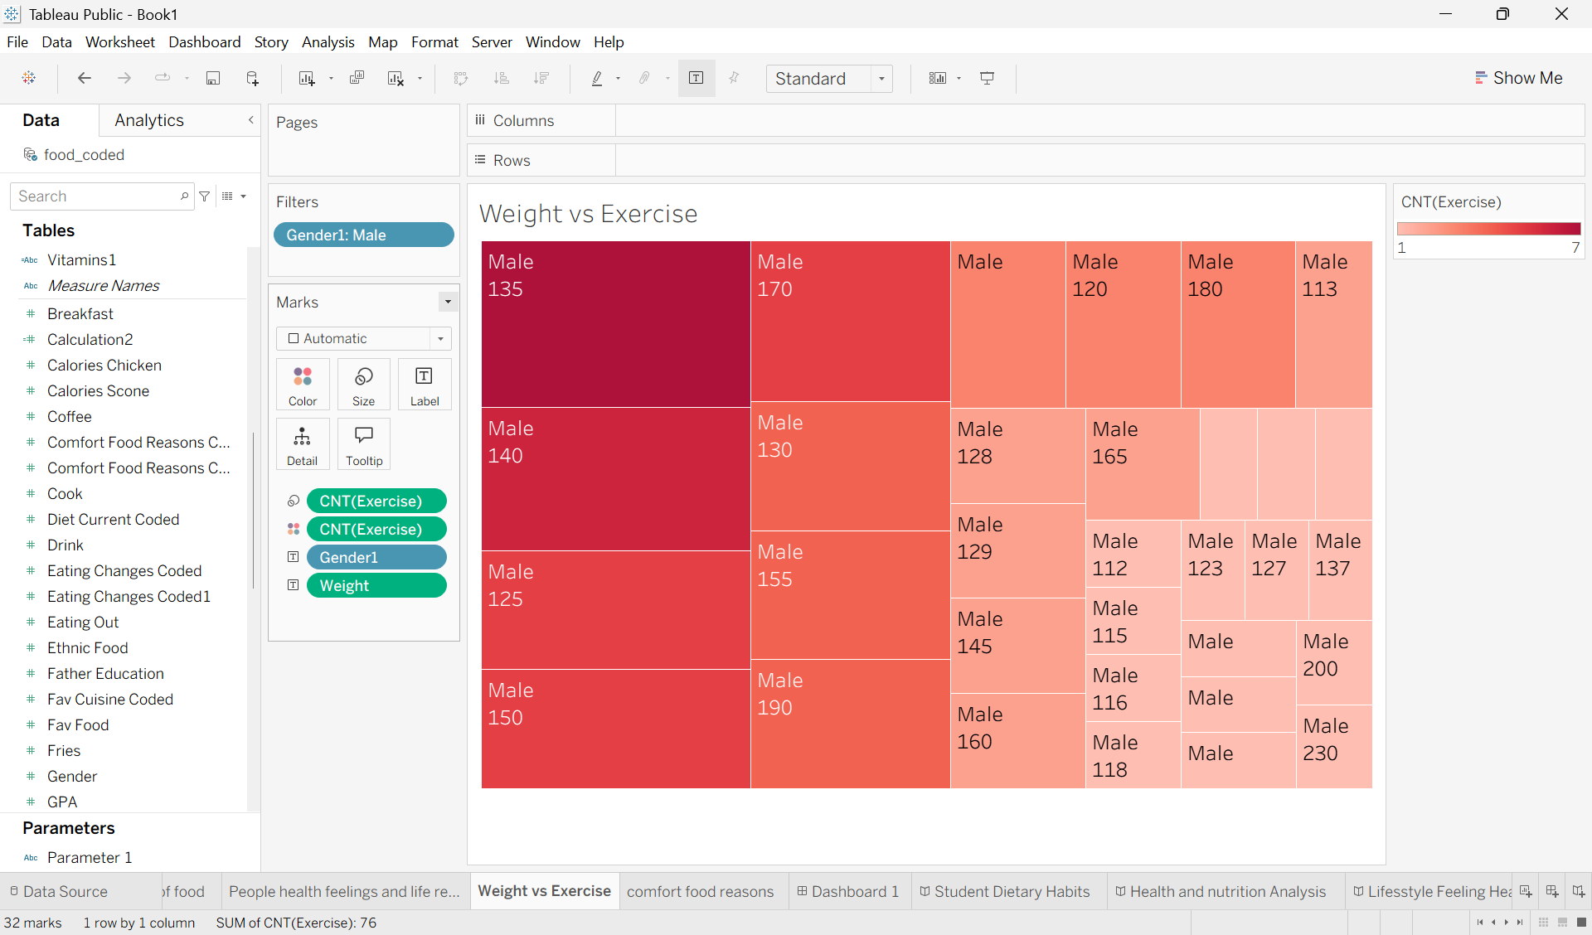

9. What are the primary reasons students consume comfort food?

